**ASSIGNMENT – 1**

**DATABASE MANAGEMENT SYSTEM**

**NAME: HASIN BANU K**

**REG NO: 192321030**

**Task 1: Entity Identification and Attributes**

**Entities and Attributes**

1. **Roads**
   * RoadID (PK)
   * RoadName
   * Length (in meters)
   * SpeedLimit (in km/h)
2. **Intersections**
   * IntersectionID (PK)
   * IntersectionName
   * Latitude
   * Longitude
3. **Traffic Signals**
   * SignalID (PK)
   * IntersectionID (FK)
   * SignalStatus (Green, Yellow, Red)
   * Timer (countdown to next change)
4. **Traffic Data**
   * TrafficDataID (PK)
   * RoadID (FK)
   * Timestamp
   * Speed (average speed on the road)
   * CongestionLevel

**Task 2: Relationship Modeling**

**Relationships and Cardinality**

1. **Roads to Intersections**
   * One-to-Many: Each road can connect to multiple intersections, but each intersection is on a single road.
   * Relationship: RoadID (PK in Roads, FK in Intersections)
2. **Intersections to Traffic Signals**
   * One-to-One: Each intersection has one traffic signal, and each traffic signal controls one intersection.
   * Relationship: IntersectionID (PK in Intersections, FK in Traffic Signals)
3. **Roads to Traffic Data**
   * One-to-Many: Each road can have multiple traffic data records collected over time.
   * Relationship: RoadID (PK in Roads, FK in Traffic Data)

**Task 3: ER Diagram Design**

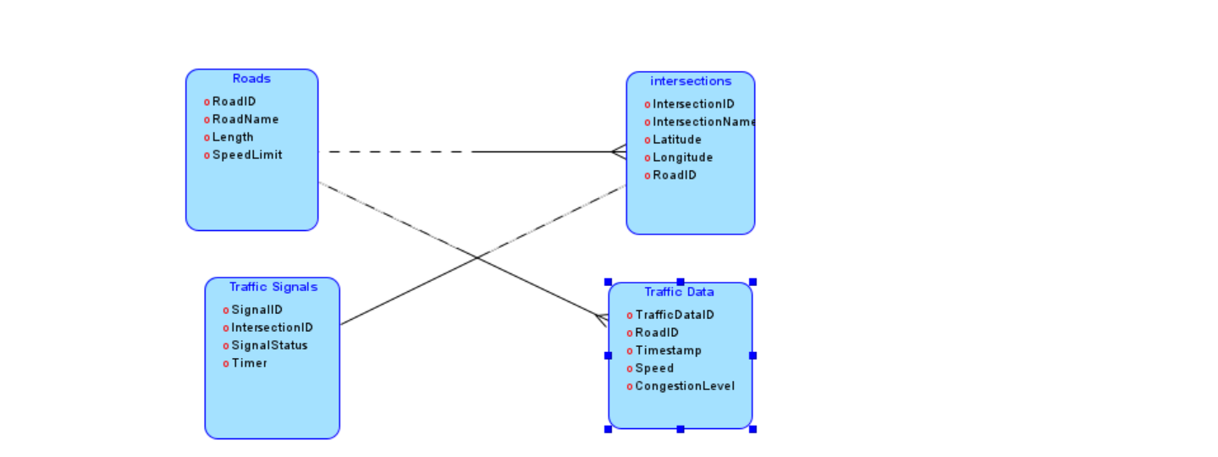

**Task 4: Relationship entity diagram**

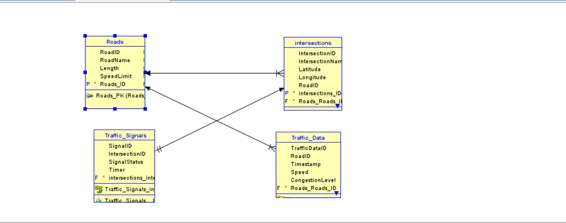

**Task 5: Justification and Normalization**

**Justification for Design Choices**

1. **Scalability**: The design allows for easy addition of new roads, intersections, and traffic signals as the city expands.
2. **Real-Time Data Processing**: Real-time traffic data is associated with specific roads, making it easier to analyze current conditions and make quick decisions.
3. **Efficient Traffic Management**: The relationships ensure that traffic signals are linked to intersections, enabling dynamic control based on real-time data.

**Normalization Considerations**

1. **First Normal Form (1NF)**: All attributes in each entity contain atomic values, ensuring no repeating groups.
2. **Second Normal Form (2NF)**: All non-key attributes are fully functionally dependent on the primary key. For instance, in the Traffic Data entity, Speed and CongestionLevel depend on TrafficDataID.
3. **Third Normal Form (3NF)**: All attributes are not only fully functionally dependent on the primary key but are also non-transitively dependent. This ensures no redundancy. For example, in the Traffic Signals entity, SignalStatus and Timer are only dependent on SignalID.

**Deliverables**

1. **ER Diagram**: As illustrated above.
2. **Entity Definitions**: Clear definitions provided in Task 1.
3. **Relationship Descriptions**: Detailed descriptions with cardinality and optionality constraints in Task 2.
4. **Justification Documen**
5. **t**: Justification for design choices and normalization considerations explained in Task 4.